# CS 340 README Template

## About the Project/Project Title

The purpose of this project is to simplify the process of searching for candidates based on the customers criteria within a MongoDB. The project includes three interactive dashboards to allow for easier visualization of requested data. The project has been built using an open-source license to allow for personal modifications of the code.

## Motivation

Per request of a client, to simplify their candidate search.

## Getting Started

* Use git or the download button on GItHub to clone the project
* Extract in any directory and modify the file to reflect your database information
* Ensure your mongodb is running
* Run the file using Python3 command

## Installation

* MongoDB - be sure to have a mongo database installed and configured
* Python3 - see Pythons site to install
* GIT (if you want to clone the project via Terminal/CMD) - GIT is built into Mac and Linux, see GIT’s site for Windows install
* Jupyter Notebook - used to run included test file. This can help when testing if personalized code works.

## Dashboard

Screenshots of included dashboards.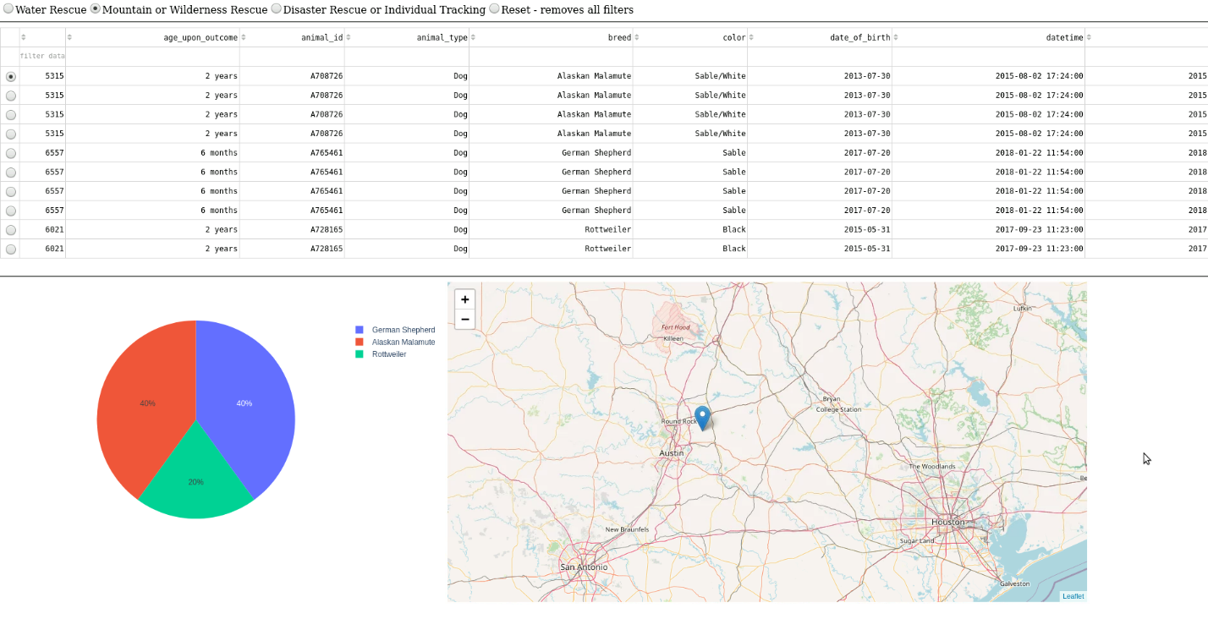

The dashboard will show data filtered based on the applied filter. The pie chart is directly influenced by the filter selected. While the map is influenced by the specific row selected, granted geolocation data is available.

Below you will find code snip-its of how the dashboard works.

## Code used to create dashboard

Radio Buttons:



Table Columns:



Table filter options:



Radio Buttons Filter Data:



Pie Chart:



Geolocation Map:



## Contact

Your name: Mike Martin